**ModelBank App**

**Class Diagram**

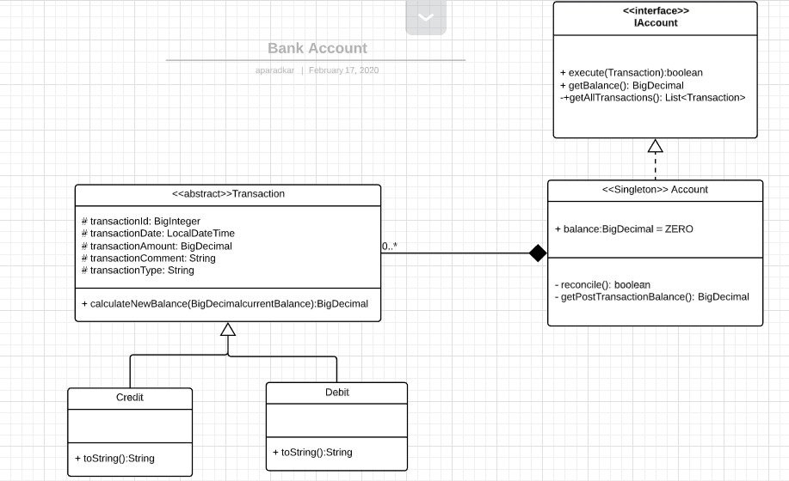

**Sequence Diagrams**

The submitted code can be executed in 2 modes using Driver classes.

1. Driver.java

This class helps run the application on console.

1. DriverMultithreaded.java

This class uses the ExecutorService to create pool of 5 threads. Each thread performs different transactions.

**Sequence Diagram A (Console Application)**

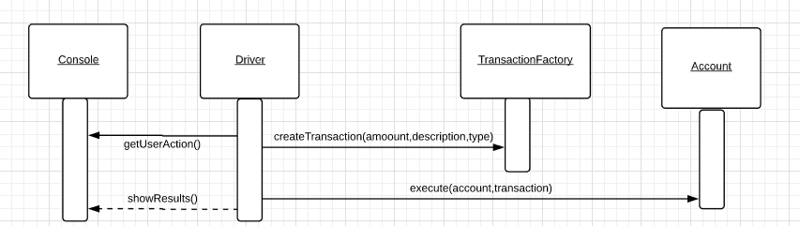

**Sequence Diagram B (Multi threaded Application)**

